2018 Innovative Smarter Lecture Award
- Introduction
  - Origins
To promote research of innovative pedagogy in Smarter Classroom and develop Smarter Lecture of team-based learning, Taiwan Technology Leadership and Instructional Technology Development Association organizes the “Innovative Smarter Lecture Award” to honor teachers who contribute to the innovative teaching model of Smarter Classroom that is capable of duplication and diffusion. Thus, the award advocates realizing student-oriented smarter education by full integration of teaching, learning, and smarter classroom.
In addition, past development of Smarter School has shown that with a visionary leader and effective teaching technology strategies, schools can create effective learning environments, guide teachers in creating Smarter Lectures, allow students to realize self-learning, and develop a school’s unique features.Therefore, the Association also offers the “Excellence Award in Technology Leadership” to honor exemplary school principals in technology leadership and publicize their leadership achievements for enhancing educational competitiveness.
  - Purpose
- Honor excellent educators and promote effective application of teaching technology.
- Honor exemplary educators in technology leadership and publicize technology leadership achievements.
- Enhance the effectiveness of technology leadership as implemented by educators.
- Encourage teachers to develop innovative teaching models of Smarter Classroom that are capable of duplication and diffusion.
- Encourage teachers to develop innovative teaching models of Smarter Classroom that are designed for team-based learning.
  - Organizer
- Organizer：Taiwan Technology Leadership and Institutional Technology Development Association
- Website：http://www.ttlitda.org/index2018_en.html
  - Schedule
- Deadline：19,May.,2018
- 2018 Gala Night & Awards Ceremony: Nov., 2018

- “Innovative Smarter Lecture Award” Qualification
  - Position and Subject
Teachers or teaching teams who use currently available teaching materials at public and private kindergartens, elementary schools, junior high, senior high, vocational schools, junior colleges, colleges, and universities are accepted with no subject or grade/class restrictions.
  - Application Categories
2018 Innovative Smarter Classroom can be divided into individual and team groups. You can choose a group to apply for according to the model you adopt.
Individual Group
- TEAM Model Smarter Classroom in IRS means each student is supplied with IRS instant feedback.
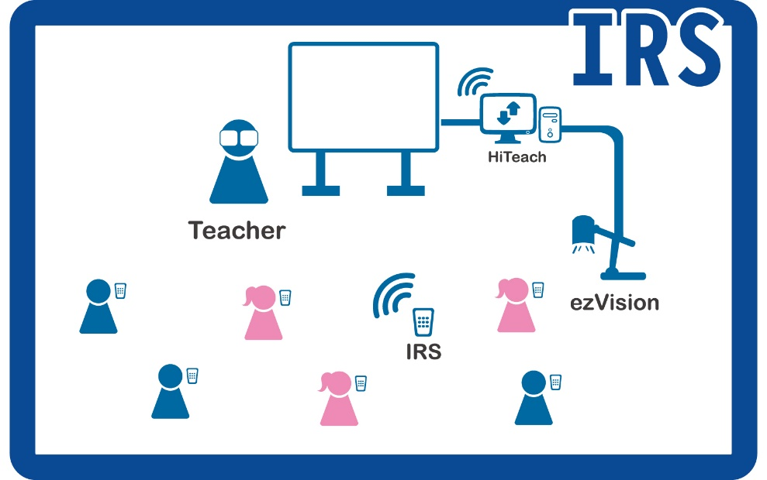
- TEAM Model Smarter Classroom in 1-to-1 means each student is supplied with a tablet computer.
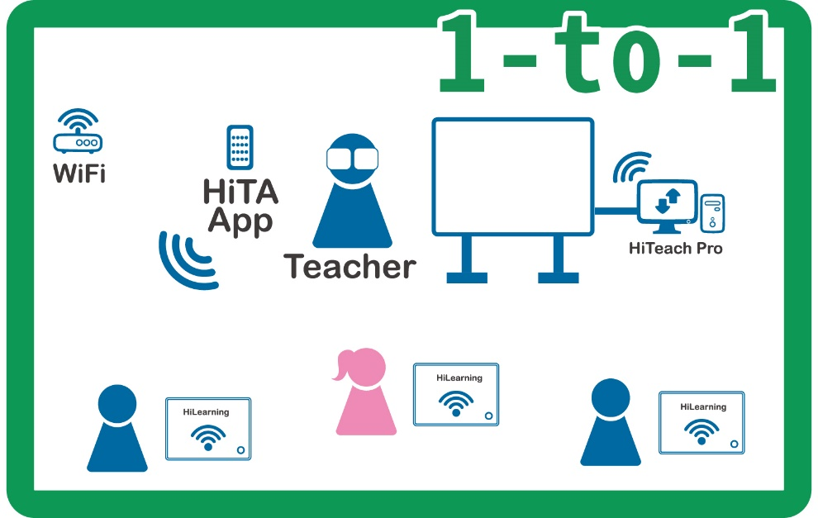
- TEAM Model Smarter Classroom in TBL means teaching strategies and classroom environment must conform to the description in “The Model of TEAM Model Team-based Learning: Vision and Practice” (HABOOK Newsletter No. HB20150115C).
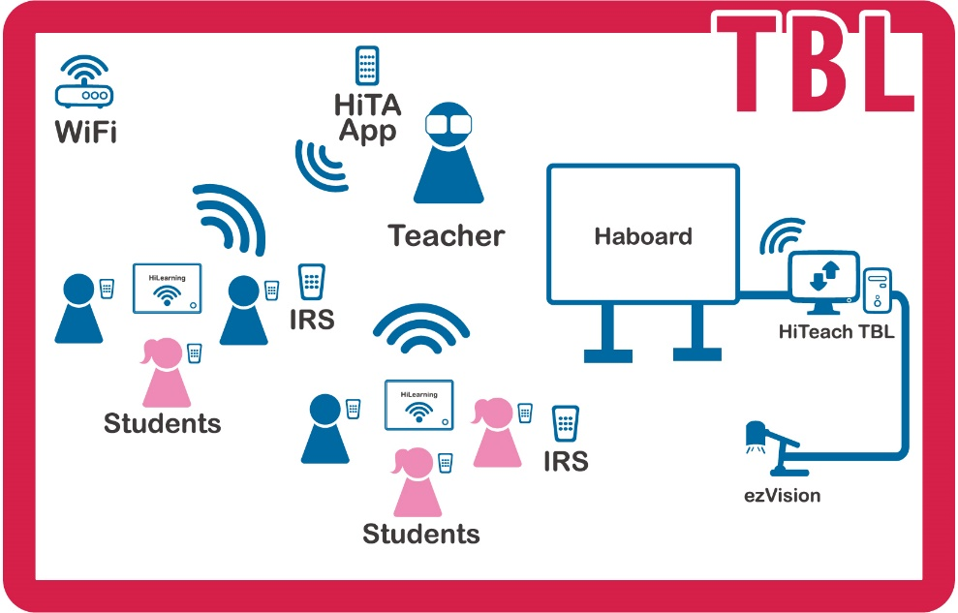

Team Group
- Each team is composed of three teachers from the same school.
- The number of teams from the same school is unlimited.
- Each teacher can only join one team and his/her teaching can apply for individual group as well.
- The three teachers on each team must teach three different subjects.
- You can adopt TBL or HiLearning model.

Fill out the application form for school teams and the form must be officially stamped by the school. Scan the application form and e-mail it to taiwantlitda@gmail.com. The winners will attend TEAM Model Teaching Competition held on November 15 and 16, 2018 to share experiences with other teams.

  - Materials and Application Procedure
1. Application form for “2018 Innovative Smarter Lecture Award” Team Group
2. TEAM Model TPC Teaching Activities Design (teaching plan)
3. One headshot and life photo of the teacher.
4. Other supporting information that is conducive in presenting the teacher’s teaching ideas, teaching progress and others.
5.Smart Video

(1.) Record your class video with your phone or a DV
Record your class and edit it with texts showing your teaching methods at specific time. Upload both videos (the original class video and the edited video) to a cloud drive such as Dropbox or Google Drive, and then e-mail the links of access to your files to us.

(2.) Use the Sokrates Video 👍Highly recommended👍
Use Sokrates Video and analyze your smart class with AI
Step 1: Complete the second stage of Smarter Teacher Movement and get an IES account.
Step 2: Record your class with HiTeach. Upload your video to the IES and e-mail the IES teacher account to us.

Please upload the application form and files to cloud storage (such as Google Drive, Dropbox, Baidu Cloud or others) and email the download link to taiwantlitda@gmail.com with a mail titled “2018 Innovative Smarter Lecture Award Application: Mr./Ms. XX from XXX School”. (After the association has reviewed the content and format comprehensiveness of the application documents, it will send a notification of successful application to the teachers and the works will enter the evaluation stage.)

  - Related Available Information
1. Video Packs(Flash Cards)
2. The Instruction of Making a Smart Video (powerpoint)
3. Apply for Smarter Education Movement and Get an IES Account (powerpoint)
4. Getting to Know about Sokrates Reports and Videos (powerpoint)
※You can download the above information on http://www.ttlitda.org/inno2018.html.

  - Selection and Reward
Taiwan Technology Leadership and Instructional Technology Development Association will select outstanding Smarter Lectures based on the “Criteria for the Innovative Smarter Lecture Award.”
- The award-winning teachers will be invited to the “2018 Global Technology Leadership & Instructional Technology Summit” awards banquet of “Global Smarter Teachers’ Night”.
- The winning team and individual teachers will attend TEAM Model Teaching Competition held on November 15 and 16, 2018 in Taipei to share experiences with other teams.
- The winning school will be rewarded on the 2018 Global Technology Leadership & Instructional Technology Summit.
- The school, teaching model and works of the award-winning teachers will be included in the 2018 Smarter Education Yearbook as the role model for hundreds of thousands of global smarter teachers.
- Teaching Pocket Tips
The winning teachers will earn the precious pocket tips, all great lessons in one hand.
- They will be added into the smarter teacher exchange platform of this association and will have the opportunities to be invited and take part in the smarter lecture seminars, experience sharing and smarter teacher professional development and training workshops.

Criteria for the 2018 Innovative Smarter Lecture Award
Content | Criteria
Description  (30%) | - Explains the teaching model of integrating education and teaching with information technology from the perspectives of subject teaching materials, pedagogy, smarter classroom and others.  - Explains the teaching strategy design of “classroom demonstration” (lively, interactive, active) and “learning insight” (precise, refined, improving) regarding smarter classroom.  - Highlights student-oriented teaching idea. Stresses and guides students to learning actively.
Teaching model (25%) | - Centering on its teaching goals, its teaching ideas, pedagogy and strategies are closely connected to them.  - The teaching model is simple, clear and highly efficient, which is conducive in duplication and dissemination.  - The teacher is capable of presenting the “precise, refined and improving” “learning insight” of smarter classroom with its teaching model design.  - The teaching model is applicable to different classes, grades, units and subjects and is worthy of duplication and dissemination.
Teacher performance (25%) | - The teaching contents demonstrate theoretical foundation, innovation and features at the same time.  - The teacher bears natural teaching manner, speaks fluently and precisely and is appealing.  - The teacher is capable of presenting the “active, lively and interactive” “teaching demonstration” of smarter classroom with the reasonable application on the supporting functions of smarter classroom.
Technology Application  （10%） | - Understands the software and hardware facilities and their applications and functions in a smarter classroom. Capable of using these technological teaching aids accurately and proficiently.  - The using time and method of technology (T) collaborate closely with the pedagogy and teaching contents (P and C) to improve teaching and learning quality and efficacy.
Content Quality（10%） | - The content of the video is complete, the image is clear, has good visual effect, and texts, pictures and other supplementary explanations are used properly.  - The content of the teaching plan is complete, clearly elaborates the teaching design of TPC, and the texts are simple and supplemented with pictures.
- Application Files and File Specification
- Rules and other information
- The video submitted must contain three sections: Smarter Model Vision, Smarter Model Description and Smarter Model Effectiveness Analysis. “Required content” contains items with required description, and “additional content” contains additional description or files that can be used for additional points during the selection stage.
- Smarter Model Vision:
【required content】: Explain the designing concepts of a smarter classroom from the perspectives of “teaching materials”, “pedagogy” and “technology”. The contents have to match with TEAM Model TPC Teaching Activities Design (teaching plan).
【additional content】: School policy and vision, community activities for the subject, teacher education activities, etc.
- Smarter Model Description:
【required content】: Name of Smarter Model, subject unit, and Smarter Model flowchart, with audio-visual description of the teaching process and detailed explanation of the application and effectiveness of the technologies involved in the teaching process.
【additional content】: Complete video recording of the lecture.
- Smarter Model Effectiveness Analysis:
【required content】: Describe the effectiveness of Smarter Model and report on the application of assistive devices and innovative teaching model. The effectiveness of Smarter Model can include comparison with previous teaching models, demonstration of students’ learning performance, showcase of student output, etc.
【additional content】: Include research or experiments conducted on the teaching model, if applicable.
- The Association provides opening sequence, scene transition animation, and titles for teaching models. Use them in editing to enhance the effectiveness of the video.
- It is recommended that the duration of the video submitted does not exceed 10minutes. Keep it concise.
Refer to this duration arrangement as a guideline: Smarter Model Vision (2 min), Smarter Model Description (6 min), and Smarter Model Effectiveness Analysis (2 min).
- Record your class with HiTeach and upload your video to the IES.
- For the video recording of the teaching process, in addition to a panoramic view of the classroom, include depiction of teaching strategies or use of assistive devices, e.g. group discussions, IRS voting, student works, teacher supervision, etc. Clearly illustrate the values of the teaching model, the teacher’s techniques, and the learning process of the students.
- Attached teaching material can include formats of HTE, ppt, doc, pdf, and other image and video formats.

- Video Specifications
- The video submission must be in .mp4 format with minimal resolution of 1080p (1920x1080).
- Due to copyright concerns, do not use a soundtrack.
- For descriptive effectiveness, supplement the video with text, graphics, and photos. Mind the focus of the video and do not allow it to go out of focus.
- Close-ups of important details of the teaching process can be included.
- Avoid noisy recording environments that can affect sound quality.
- Use tripods for cameras to prevent wobbling or tilting image.

- Photo Specifications
- The resolution of the photos should be better than 300 dpi (around 2048 × 1536).
- The file format should be either JPG or PNG.
- It is more appropriate to choose photos without gestures or other lively movements.
- Please choose photos with ones looking straight ahead and nothing covering the face (such as sunglasses or hats).

Appendix 1: Innovative Smarter Lecture Award 2018 Application Form
Innovative Smarter Lecture Award 2018
Application Form
Teacher Information
Name |  |  |  | Photo |  | Date of Birth  (YYYY/MM/DD)
Gender |  | □ Female  □ Male |  |  |  | Position
School (Institute) |  |  |  |  |  | Years of Teaching Experience
School Phone |  |  |  |  |  | School Fax
Mobile Phone |  |  |  |  |  | e-Mail
School Address
Education |  | Degree | Name of school |  |  |  |  | Major / Area |  | From / To
Experience |  | School / Organization |  |  | Position |  |  |  |  | From / To
Achievements |  | 1.  2.  3.  4.  5.
□ IRS TMSC / □ TBL TMSC / □ 1-to-1 TMSC |  |  |  |  |  |  | Level / Year
□Primary school / □Secondary school / □ Other:
Topic |  |  |  |  |  |  | Subject

TEAM Model TPC Teaching Activities Design
- Brief Introduction on Teaching Ideas and Pedagogy
- Explanation on teaching materials

- Explanation on the pedagogy

- Explanation on technological applications

- Teaching model

Model structure  (Flowchart) | Use a module.
Model description  (Add steps when necessary. Include photos.) | Steps |  | Step description  (within 50 words) | Photos
 | Step 1:
 | Step 2:
 | Step 3:
 | Step 4:
 | Step 5:

- TEAM Model TPC Teaching Activities Design
Subject |  | Material
Topic |  | Level / Year
Designer |  | Duration
Teaching Environment
Learning Objectives
Evaluation of Outcomes
Teaching  Step | Teaching process (Pedagogy、Content) |  |  | Time | Technology application (T) | Teaching evaluation (P、C)

Appendix 2: Application Form for “2018 Innovative Smarter Lecture Award” Team Group
Application Form for “2018 Innovative Smarter Lecture Award” Team Group
School |  |  | Organization
Phone |  |  | E-Mail
Address
Our school recognizes the following teachers as our representatives to apply for the 2018 Innovative Smarter Lecture Award under team group.
Name(Teacher 1)：
Subject： |  |  |  | Grade：
Name(Teacher 2)：
Subject： |  |  |  | Grade：
Name(Teacher 3)：
Subject： |  |  |  | Grade：
School Stamp or  Headmaster’s Signature |  |  |  | Applicant’s Signature
※Please application form is officially stamped by the school and e-mail it to taiwantlitda@gmail.com.
Organizer：Taiwan Technology Leadership and Institutional Technology Development Association
E-mail：taiwantlitda@gmail.com
Website：http://www.ttlitda.org/inno2018.html

